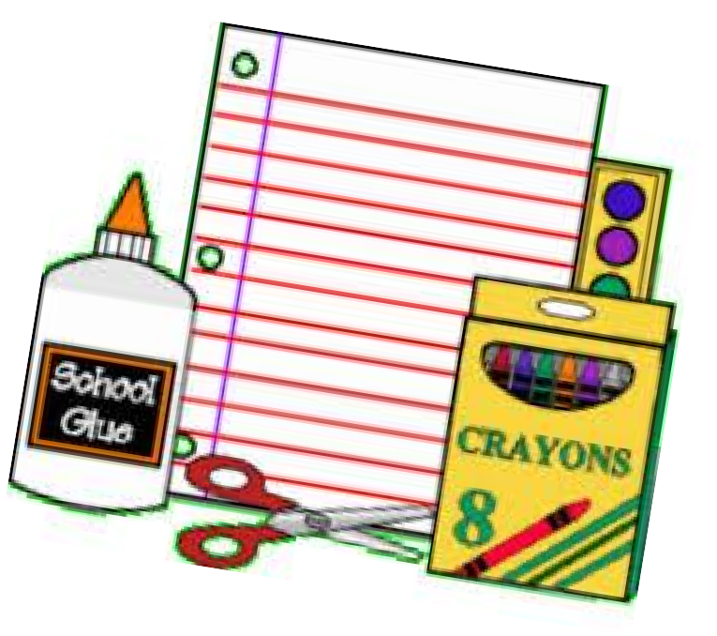

GRADE 4 SUPPLY LIST

20 HB pencils pre-sharpened
(will need more throughout the year)
1 red pen
4 blue pens
1 pencil crayons pre-sharpened (24)
- Crayola super tip felt markers (12)
- highlighters
4 white erasers
2 glue sticks (40 g)
- scribblers – 40 pages - lined
- duotangs – (plastic duotangs are more durable)
* 1 each of red, blue, green, yellow, orange
1 pencil box (case to fit in desk)
1 scissors-pointed
1 metric ruler (transparent)
- pencil sharpener with lid
- pocket folders
4 whiteboard markers
(for use on individual whiteboards)
- 3” x 3” pads of sticky notes
1 4” math protractor

Additional items:
1 pair indoor running shoes
1 headphones/earbuds

Please note white out will not be allowed in the classroom.

